Pine Mountain Estates

Disaster Preparedness
Plan

Introduction
We never want to be in a situation where we must decide if we need to evacuate or stay and defend our homes or property. But either way, our number one goal is to keep ourselves, our family and our pets safe from harm.
In most cases, because of the advance technology of meteorologist, if there’s a natural disaster headed our way, we may get plenty of warning. Bur remember, this isn’t always the case, therefore, we must always be prepared.
This booklet will not provide you with all the answers to your questions – but what it will provide you with the essentials to create a plan, needed contents for your Disaster Preparedness Kit, emergency phone numbers and more. For complete details on any natural disaster that may happen here on Pine Mountain, visit our website: PineMountainNC.com.

Table of Contents

Evacuation Map of Pine Mountain 4
Ways to be Notified 5
Emergency Phone Numbers 6
Types of Natural Disasters 8
Preparation Kit 10
Safety 11
Special Notes 12

For complete details contained in this booklet, visit our website: PineMountainNC.com.
Evacuation Plan
Not everyone will be taking the same route off Pine Mountain as you. Plus, not everyone will be leaving the same time. Understand that it will take others longer to pack, load the car and hustle everyone in the car, truck or van, so take your time to do it right.
Pine Mountain Evacuation Routes
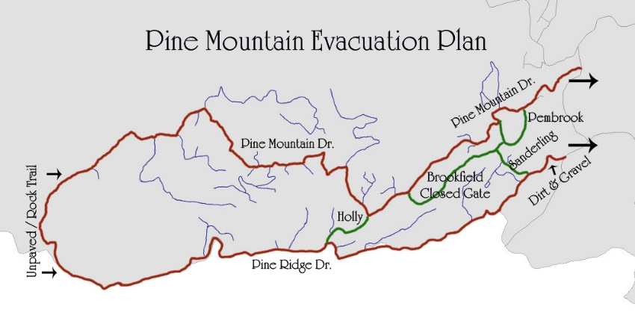
In most cases, all residents will be evacuating out either Pine Mountain Drive or Pine Ridge Drive. The difference will be based on the natural disaster we’re facing.
Know your route and how much time it will take to get out – in case of an emergency, this can make a substantial difference to your safety.
Ways to be Notified
There are several ways to keep Pine Mountain residents and land owners informed of Emergency Situations:
- Phonevite: The POA Office keeps a listing of all residents and landowners in case of an emergency. Phone calls and/or emails will go out immediately upon notification from local officials on situations that will put us in harm’s way. Always make sure your information is current and up-to-date.
- Pine Mountain Facebook: The Pine Mountain Facebook page is updated immediately when any of the following emergency programs report local dangers.
  - Foothills Weather Network
  - Burke County Emergency Reporter
  - Burke County, NC
  - City of Morganton, NC Government
- Smart Phone Apps:
  - Burke County Emergency Reporter
  - Foothills Weather Network
  - Burke County, NC
  - City of Morganton, NC Government

Emergency Phone Numbers
 |  | Phone Number
Emergency Services:
 | EMERGENCY | 911
 | Ambulance, Burke County | 828-437-1111
 | Fire Department, South Mt | 828-438-8300
 | Sheriff's Dept, Burke County | 828-438-5500
 | South Mt Park Rangers | 828-433-4772
 | Rutherford Electric - Forest City | 800-521-0920
 | Rutherford Electric - Morganton | 800-228-9756
Hospitals / Clinics (People)
 | Blue Ridge Carolinas Health Care | 828-580-5000
 | Broughton Psychiatric Hospital | 828-433-2111
 | Frye Regional Hospital | 828-315-5000
 | Grace Hospital | 828-580-5000
 | Hickory Veterans Clinic | 828-431-5600
 | Valdese Hospital | 828-874-2251

Emergency Phone Numbers
Continued

Animal Hospitals / Care /Control
 | Burke County Animal Control | 828-438-5465
 | Partners for Cats (Jean) | 828-437-8769
 | Friends for Animals | 828-433-1115
 | REASON | 828-403-3675
 | Vale Veterinary Hospital | 704-462-2901
Pine Mountain Information
 | POA Office | 828-437-4894
 | POA Maintenance, Jimmy | 828-315-1516
 | POA Maintenance, Matt | 828-205-7081

Add your own important names & phone numbers:

Types of Natural Disasters
According to the American Red Cross, there are over 22 diverse types of Natural Disasters we need to be aware of and prepared for based on your physical location.
We must know how to create an Emergency Plan, have a Kit ready for our family and pets and be prepared. By doing these simple things, the less likely anyone will panic in case of an emergency.
Here on Pine Mountain and the purpose of this booklet, we’ve identified the Top 4 Natural Disasters:
- Wildfires: Fires can spread quickly, so they can become life threatening in 2-minutes and destroy a home in as little as 5-minutes. As the fire burns, poisonous gases are sent into the air that can make you feel drowsy and less in control of your thinking and movements.
- Winter Storms: The Natural Weather Service refers to Winter Storms as the “deceptive killers” because most deaths aren’t a direct result of the storms. People are injured or killed in traffic accidents on icy roads and suffer from hypothermia due to being cold for an extended period.
- Thunderstorms: Thunderstorms can cause a lot of damage and very dangerous weather emergencies: high winds, tornadoes, lightning, power outages and more.
- Landslides: Landslides can be started by storms, earthquakes, fires and man-made construction. They move quickly, striking with little to no warning at very fast speeds. Landslides can also move several miles from their starting point taking trees, boulders, houses, vehicles and other materials with them.
There are other situations we must be aware of and how to protect ourselves: Home Fires, Flood, Heat Wave, Power Outage and more are identified with appropriate information on the Pine Mountain website: PineMountainNC.com.

Preparedness Kits
When preparing for a possible emergency, it’s best to think first about the basics of survival: fresh water, food, clean air and warmth.
Basic Kit / Car Mobile Survival Kit:
- Nylon carrying bag or day-pack
- Transistor radio & extra batteries
- Flashlight & extra batteries
- First Aid kit
- Whistle to signal for help
- Blanket, sleeping bag or space blanket
- Pre-moistened towelettes, toilet paper & tissues
- Gloves
- Can opener
- Fire Extinguisher (ABC type)
- Sealable plastic bags
- Small tool box
- Matches & lighter
- Aspirin or pain relief medication
- Insect spray
- Hydrogen peroxide
- Band-Aids, large & small; bandages
Safety
Create a Safety Plan – just in case. It’s easier to follow a plan than to wait to the last minute and try to figure out what you need to do or how to do it.
Things you need to know:
- Personal & Household Information:
  - Home mortgage & insurance doc.’s
  - Personal IDs & life insurance
  - Driver’s license, passports
  - Health records / insurance
- School & Work place emergency plans.
- Out of town contact numbers
- Create an Emergency Meeting place, if you and your family could be separated.
- Create a Family Emergency Communication Plan.
Pet Safety:
- ID your pet. Keep cat & dog collars and ID tags up-to-date
- Put your cell phone # on your pet’s tag
- If you evacuate, take your pet.
- If you stay home, keep your pet safe.
Additional info: www.PineMountainNC.com
Stay Alert
Disaster Preparedness Plans are designed to keep individuals, families and pets safe and out of harm’s way.
Plan an evacuation route – you hope you never need one, but if you do – you’ll be glad you did.
Stay alert of all weather conditions and pay attention to all broadcasted warnings that will affect your area.
In addition to personal safety, Pine Mountain Estates belongs to the nation’s FIREWISE Community program. This program encourages and acknowledges communities whose actions reduce the community’s natural wildfire risk.
For additional information on FIREWISE, contact the Pine Mountain Estates Office and/or visit Pine Mountain website: www.PineMountainNC.com.

Stay Safe

